LAB EXPERIMENT RECORD

SET 22: TIME SERIES ANALYSIS

Department | AIDS
Course Code / Course Name | DSA0601 / Data Handling and Visualization
Experiment | Data Visualization using R
Name | M.Teja kumar
Register Number | 192424308
Date | 15 OCTOBER 2026
Day | Thursday

Aim
To analyze monthly sales data using a time series line chart, a scatter plot, an interactive dashboard, and an autocorrelation plot in R and Shiny

Dataset: Monthly Sales

Month | Sales ($)
January | 15000
February | 18000
March | 22000
April | 20000
May | 23000

PROGRAM 1: Time Series Line Chart of Monthly Sales
To visualize the trend in monthly sales using a time series line chart with appropriate axis labels and title.
# # Dataset
month <- c("January", "February", "March", "April", "May") sales <- c(15000, 18000, 22000, 20000, 23000)
# Time Series Line Chart plot(
sales, type = "o",
xaxt = "n", xlab = "Month",
ylab = "Sales ($)",
main = "Monthly Sales Trend", col = "blue",

pch = 19
)
axis(1, at = 1:5, labels = month)
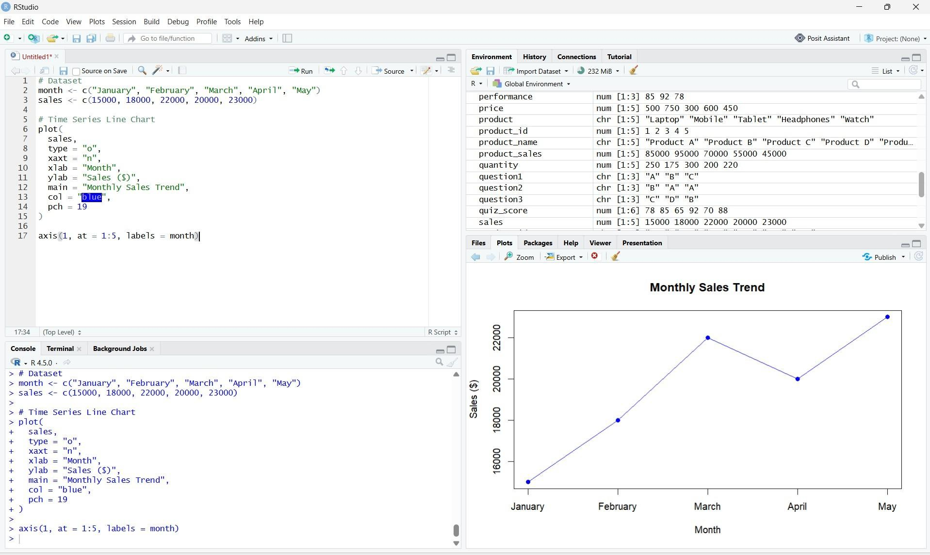
Observation: Sales increase from January to March, decrease slightly in April, and reach their highest value of $23,000 in May.

PROGRAM 2: Scatter Plot of Advertising Budget vs Monthly Sales
To explore the relationship between advertising expenditure and monthly sales using a scatter plot
# Sample Dataset
month <- c("January", "February", "March", "April", "May") advertising <- c(5000, 6000, 7000, 8000, 9000)
sales <- c(15000, 18000, 22000, 20000, 23000)
# Scatter Plot plot(
advertising, sales,
main = "Advertising Budget vs Monthly Sales", xlab = "Advertising Budget ($)",
ylab = "Monthly Sales ($)", pch = 19,
col = "red"
)

text(
advertising, sales,
labels = month, pos = 3
))

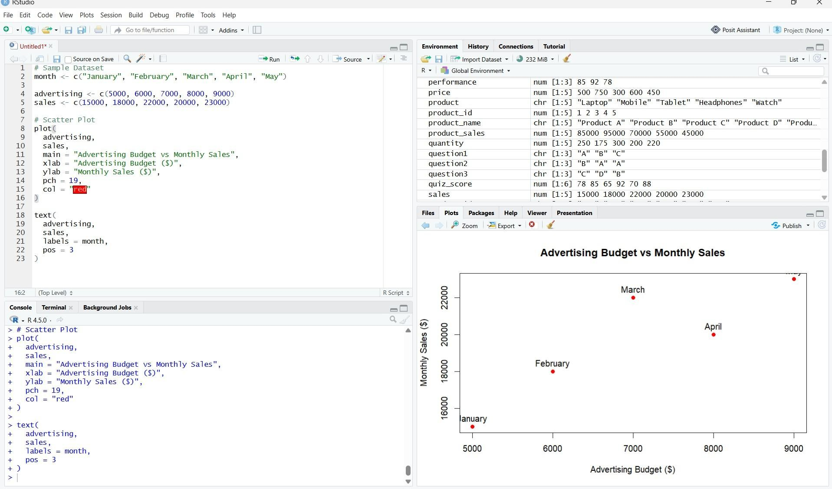
Observation: the sample values show a generally positive relationship between advertising budget and sales. However, this does not prove that increased advertising causes higher sales..

PROGRAM 3: Interactive Monthly Sales Dashboard
To create an interactive dashboard combining a line chart for monthly sales and a pie chart displaying sales distribution across products.
library(shiny)

month <- c("January", "February", "March", "April", "May") sales <- c(15000, 18000, 22000, 20000, 23000)

product <- c("Product A", "Product B", "Product C") product_sales <- c(30000, 25000, 21000)

ui <- fluidPage(
titlePanel("Monthly Sales Dashboard"),

tabsetPanel(
tabPanel("Sales Trend", plotOutput("line")), tabPanel("Product Sales", plotOutput("pie"))
)
)
server <- function(input, output) { axis(1, at = 1:5, labels = month)
})
output$pie <- renderPlot({ pie(
product_sales,
labels = paste(product, product_sales),
main = "Sales Distribution Across Products", col = c("lightblue", "lightgreen", "orange")
)
})
}
shinyApp(ui = ui, server = server))

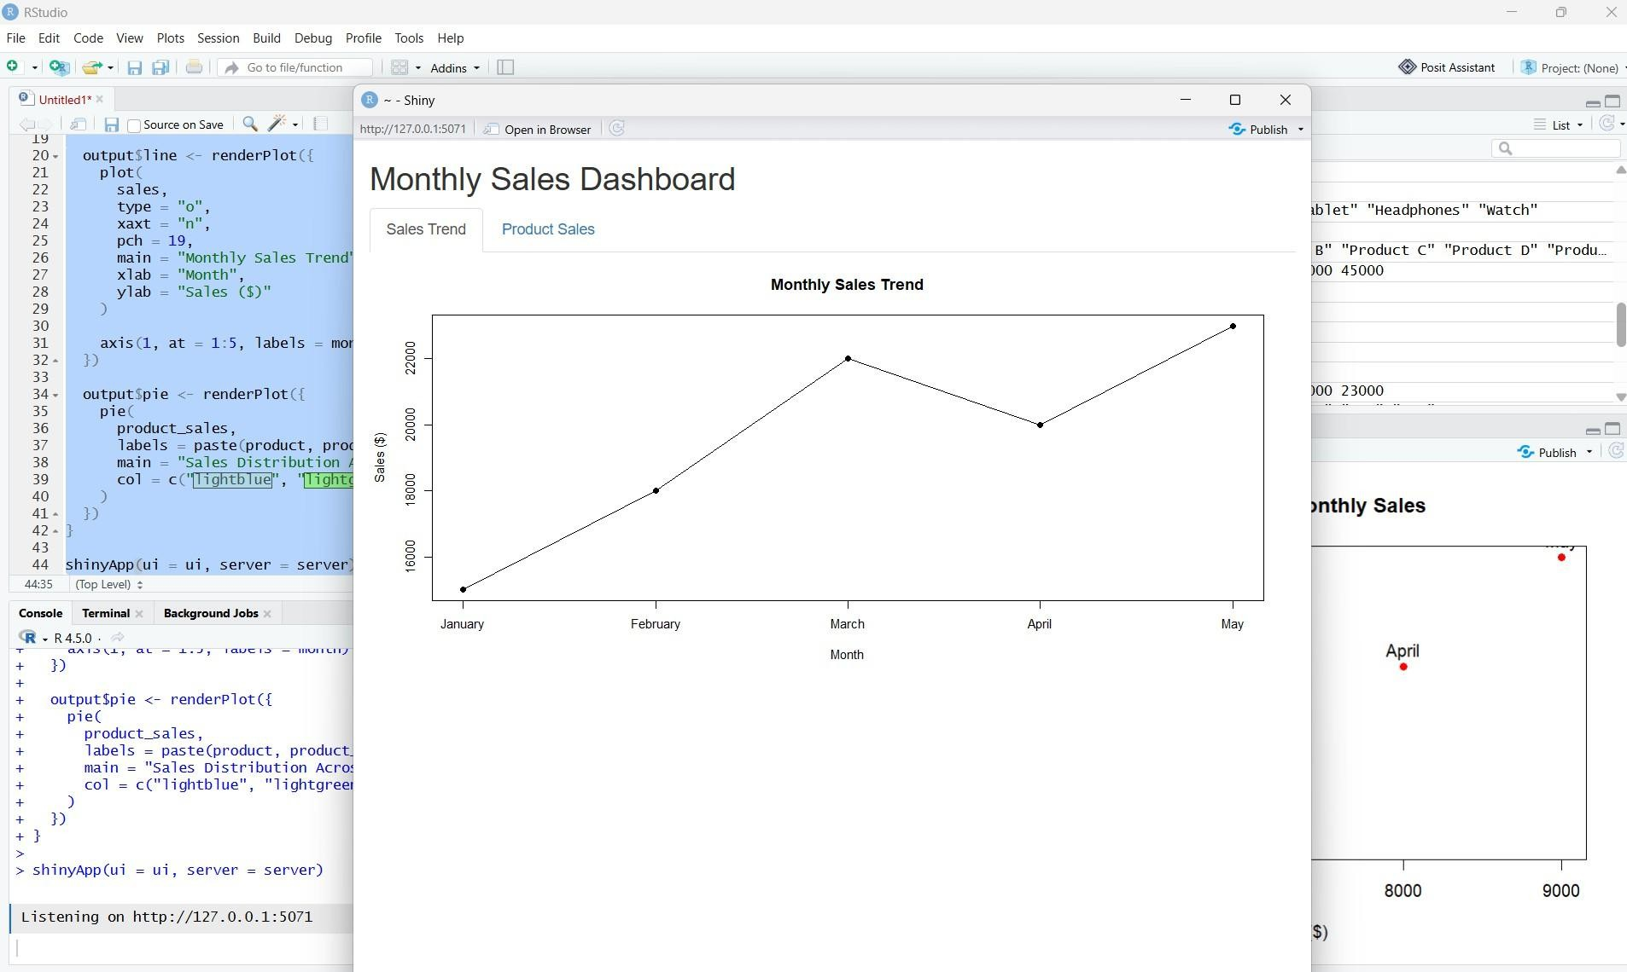
Insight: The dashboard allows users to switch between the monthly sales trend and the illustrative product sales distribution..

PROGRAM 4: Autocorrelation Plot
To create an autocorrelation plot to examine possible patterns and seasonality in monthly sales.
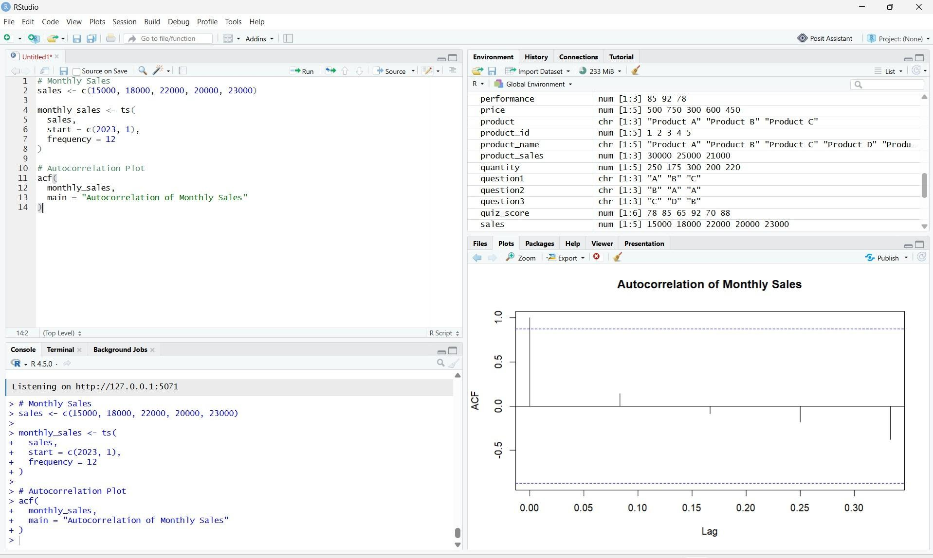
# Monthly Sales
sales <- c(15000, 18000, 22000, 20000, 23000)

monthly_sales <- ts( sales,
start = c(2023, 1), frequency = 12
)

# Autocorrelation Plot acf(
monthly_sales,
main = "Autocorrelation of Monthly Sales"
)}

Observation: The autocorrelation plot shows correlations at different time lags. Since only five monthly observations are available, reliable conclusions about seasonality cannot be made.

Procedure
- Create vectors for months and sales values.
- Use plot() and axis() to visualize the monthly sales trend.
- Create advertising and sales vectors and use plot() to examine their relationship.
- Use Shiny to combine the sales line chart and product sales pie chart in an interactive dashboard.
- Convert the sales values into a time series using ts() and create an autocorrelation plot using acf().
- Run each program in RStudio and observe the results.
.

Result
Monthly sales data was successfully analyzed using a line chart, scatter plot, interactive dashboard, and autocorrelation plot. The visualizations helped examine sales trends and possible relationships in the data.

